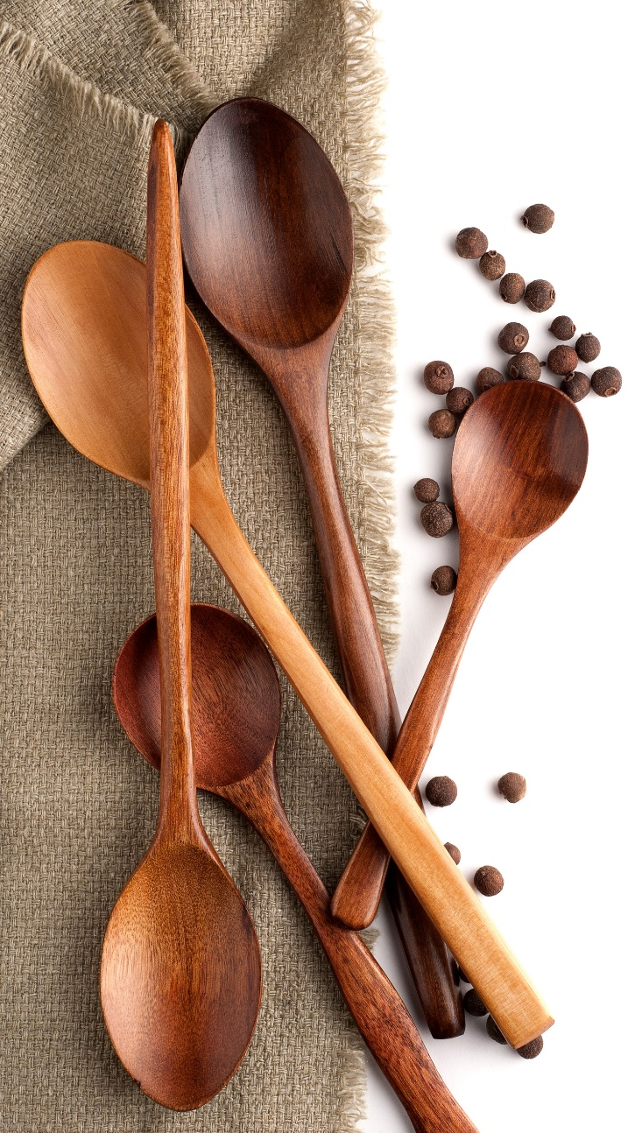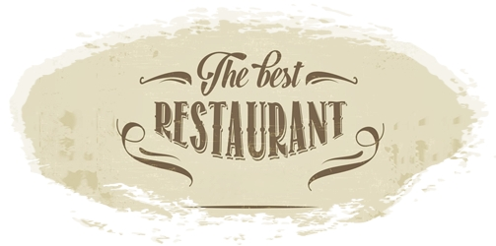

**Philly Cheese Steak Sandwich $6.79**All natural steak sirloin made with sauteed mushroom, green pepper and onion topped with melted provolone cheese all on a toasted hoagie.

**Philly Cheese Steak Sandwich $6.79**All natural steak sirloin made with sauteed mushroom, green pepper and onion topped with melted provolone cheese all on a toasted hoagie.

**Philly Cheese Steak Sandwich $6.79**All natural steak sirloin made with sauteed mushroom, green pepper and onion topped with melted provolone cheese all on a toasted hoagie.

**Philly Cheese Steak Sandwich $6.79**All natural steak sirloin made with sauteed mushroom, green pepper and onion topped with melted provolone cheese all on a toasted hoagie.

**Philly Cheese Steak Sandwich $6.79**All natural steak sirloin made with sauteed mushroom, green pepper and onion topped with melted provolone cheese all on a toasted hoagie.

**Philly Cheese Steak Sandwich $6.79**All natural steak sirloin made with sauteed mushroom, green pepper and onion topped with melted provolone cheese all on a toasted hoagie.

**Philly Cheese Steak Sandwich $6.79**All natural steak sirloin made with sauteed mushroom, green pepper and onion topped with melted provolone cheese all on a toasted hoagie.

**Chef’s Favorites**

**Philly Cheese Steak Sandwich $6.79**All natural steak sirloin made with sauteed mushroom, green pepper and onion topped with melted provolone cheese all on a toasted hoagie.

**House Gyro Sandwich Combo $9.99**Our house gyro made with beef and lamb meat on a toasted pita. Comes with lettuce, tomato, onion, feta cheese and tzatziki sauce. Our combos come with one side and a fountain drink/coffee.

**MENU**

**Philly Cheese Steak Sandwich $6.79**All natural steak sirloin made with sauteed mushroom, green pepper and onion topped with melted provolone cheese all on a toasted hoagie.

**Breakfast Sandwiches and Omelets**

**Lunch Menu**

**Vegetarian**

**Dinners**

**Philly Cheese Steak Sandwich $6.79**All natural steak sirloin made with sauteed mushroom, green pepper and onion topped with melted provolone cheese all on a toasted hoagie.

**Philly Cheese Steak Sandwich $6.79**All natural steak sirloin made with sauteed mushroom, green pepper and onion topped with melted provolone cheese all on a toasted hoagie.

**Philly Cheese Steak Sandwich $6.79**All natural steak sirloin made with sauteed mushroom, green pepper and onion topped with melted provolone cheese all on a toasted hoagie.

**Philly Cheese Steak Sandwich $6.79**All natural steak sirloin made with sauteed mushroom, green pepper and onion topped with melted provolone cheese all on a toasted hoagie.

**Philly Cheese Steak Sandwich $6.79**All natural steak sirloin made with sauteed mushroom, green pepper and onion topped with melted provolone cheese all on a toasted hoagie.

**Philly Cheese Steak Sandwich $6.79**All natural steak sirloin made with sauteed mushroom, green pepper and onion topped with melted provolone cheese all on a toasted hoagie.

**Philly Cheese Steak Sandwich $6.79**All natural steak sirloin made with sauteed mushroom, green pepper and onion topped with melted provolone cheese all on a toasted hoagie.

**Philly Cheese Steak Sandwich $6.79**All natural steak sirloin made with sauteed mushroom, green pepper and onion topped with melted provolone cheese all on a toasted hoagie.

**Philly Cheese Steak Sandwich $6.79**All natural steak sirloin made with sauteed mushroom, green pepper and onion topped with melted provolone cheese all on a toasted hoagie.

**Philly Cheese Steak Sandwich $6.79**All natural steak sirloin made with sauteed mushroom, green pepper and onion topped with melted provolone cheese all on a toasted hoagie.

**Philly Cheese Steak Sandwich $6.79**All natural steak sirloin made with sauteed mushroom, green pepper and onion topped with melted provolone cheese all on a toasted hoagie.

**Philly Cheese Steak Sandwich $6.79**All natural steak sirloin made with sauteed mushroom, green pepper and onion topped with melted provolone cheese all on a toasted hoagie.

**Philly Cheese Steak Sandwich $6.79**All natural steak sirloin made with sauteed mushroom, green pepper and onion topped with melted provolone cheese all on a toasted hoagie.

**Philly Cheese Steak Sandwich $6.79**All natural steak sirloin made with sauteed mushroom, green pepper and onion topped with melted provolone cheese all on a toasted hoagie.

**Philly Cheese Steak Sandwich $6.79**All natural steak sirloin made with sauteed mushroom, green pepper and onion topped with melted provolone cheese all on a toasted hoagie.

**Philly Cheese Steak Sandwich $6.79**All natural steak sirloin made with sauteed mushroom, green pepper and onion topped with melted provolone cheese all on a toasted hoagie.

**Philly Cheese Steak Sandwich $6.79**All natural steak sirloin made with sauteed mushroom, green pepper and onion topped with melted provolone cheese all on a toasted hoagie.

**Philly Cheese Steak Sandwich $6.79**All natural steak sirloin made with sauteed mushroom, green pepper and onion topped with melted provolone cheese all on a toasted hoagie.

**Desserts**

**Salads**

**Philly Cheese Steak Sandwich $6.79**All natural steak sirloin made with sauteed mushroom, green pepper and onion topped with melted provolone cheese all on a toasted hoagie.

**Philly Cheese Steak Sandwich $6.79**All natural steak sirloin made with sauteed mushroom, green pepper and onion topped with melted provolone cheese all on a toasted hoagie.

**Philly Cheese Steak Sandwich $6.79**All natural steak sirloin made with sauteed mushroom, green pepper and onion topped with melted provolone cheese all on a toasted hoagie.

**Philly Cheese Steak Sandwich $6.79**All natural steak sirloin made with sauteed mushroom, green pepper and onion topped with melted provolone cheese all on a toasted hoagie.

**Philly Cheese Steak Sandwich $6.79**All natural steak sirloin made with sauteed mushroom, green pepper and onion topped with melted provolone cheese all on a toasted hoagie.

**Philly Cheese Steak Sandwich $6.79**All natural steak sirloin made with sauteed mushroom, green pepper and onion topped with melted provolone cheese all on a toasted hoagie.

**Philly Cheese Steak Sandwich $6.79**All natural steak sirloin made with sauteed mushroom, green pepper and onion topped with melted provolone cheese all on a toasted hoagie.

**Philly Cheese Steak Sandwich $6.79**All natural steak sirloin made with sauteed mushroom, green pepper and onion topped with melted provolone cheese all on a toasted hoagie.

**Philly Cheese Steak Sandwich $6.79**All natural steak sirloin made with sauteed mushroom, green pepper and onion topped with melted provolone cheese all on a toasted hoagie.

**Philly Cheese Steak Sandwich $6.79**All natural steak sirloin made with sauteed mushroom, green pepper and onion topped with melted provolone cheese all on a toasted hoagie.

**Philly Cheese Steak Sandwich $6.79**All natural steak sirloin made with sauteed mushroom, green pepper and onion topped with melted provolone cheese all on a toasted hoagie.

**Philly Cheese Steak Sandwich $6.79**All natural steak sirloin made with sauteed mushroom, green pepper and onion topped with melted provolone cheese all on a toasted hoagie.

**Philly Cheese Steak Sandwich $6.79**All natural steak sirloin made with sauteed mushroom, green pepper and onion topped with melted provolone cheese all on a toasted hoagie.

**Philly Cheese Steak Sandwich $6.79**All natural steak sirloin made with sauteed mushroom, green pepper and onion topped with melted provolone cheese all on a toasted hoagie.

**Philly Cheese Steak Sandwich $6.79**All natural steak sirloin made with sauteed mushroom, green pepper and onion topped with melted provolone cheese all on a toasted hoagie.

**Philly Cheese Steak Sandwich $6.79**All natural steak sirloin made with sauteed mushroom, green pepper and onion topped with melted provolone cheese all on a toasted hoagie.

**Philly Cheese Steak Sandwich $6.79**All natural steak sirloin made with sauteed mushroom, green pepper and onion topped with melted provolone cheese all on a toasted hoagie.

**Philly Cheese Steak Sandwich $6.79**All natural steak sirloin made with sauteed mushroom, green pepper and onion topped with melted provolone cheese all on a toasted hoagie.

**Kids Menu**

**Beverages**

**Philly Cheese Steak Sandwich $6.79**All natural steak sirloin made with sauteed mushroom, green pepper and onion topped with melted provolone cheese all on a toasted hoagie.

**Philly Cheese Steak Sandwich $6.79**All natural steak sirloin made with sauteed mushroom, green pepper and onion topped with melted provolone cheese all on a toasted hoagie.

**Philly Cheese Steak Sandwich $6.79**All natural steak sirloin made with sauteed mushroom, green pepper and onion topped with melted provolone cheese all on a toasted hoagie.

**Philly Cheese Steak Sandwich $6.79**All natural steak sirloin made with sauteed mushroom, green pepper and onion topped with melted provolone cheese all on a toasted hoagie.

**Philly Cheese Steak Sandwich $6.79**All natural steak sirloin made with sauteed mushroom, green pepper and onion topped with melted provolone cheese all on a toasted hoagie.

**Philly Cheese Steak Sandwich $6.79**All natural steak sirloin made with sauteed mushroom, green pepper and onion topped with melted provolone cheese all on a toasted hoagie.

**Philly Cheese Steak Sandwich $6.79**All natural steak sirloin made with sauteed mushroom, green pepper and onion topped with melted provolone cheese all on a toasted hoagie.

**Philly Cheese Steak Sandwich $6.79**All natural steak sirloin made with sauteed mushroom, green pepper and onion topped with melted provolone cheese all on a toasted hoagie.

**Philly Cheese Steak Sandwich $6.79**All natural steak sirloin made with sauteed mushroom, green pepper and onion topped with melted provolone cheese all on a toasted hoagie.

**Philly Cheese Steak Sandwich $6.79**All natural steak sirloin made with sauteed mushroom, green pepper and onion topped with melted provolone cheese all on a toasted hoagie.

**Philly Cheese Steak Sandwich $6.79**All natural steak sirloin made with sauteed mushroom, green pepper and onion topped with melted provolone cheese all on a toasted hoagie.

**Philly Cheese Steak Sandwich $6.79**All natural steak sirloin made with sauteed mushroom, green pepper and onion topped with melted provolone cheese all on a toasted hoagie.

**Philly Cheese Steak Sandwich $6.79**All natural steak sirloin made with sauteed mushroom, green pepper and onion topped with melted provolone cheese all on a toasted hoagie.

**Philly Cheese Steak Sandwich $6.79**All natural steak sirloin made with sauteed mushroom, green pepper and onion topped with melted provolone cheese all on a toasted hoagie.

**Philly Cheese Steak Sandwich $6.79**All natural steak sirloin made with sauteed mushroom, green pepper and onion topped with melted provolone cheese all on a toasted hoagie.

**Philly Cheese Steak Sandwich $6.79**All natural steak sirloin made with sauteed mushroom, green pepper and onion topped with melted provolone cheese all on a toasted hoagie.

**Philly Cheese Steak Sandwich $6.79**All natural steak sirloin made with sauteed mushroom, green pepper and onion topped with melted provolone cheese all on a toasted hoagie.

**Philly Cheese Steak Sandwich $6.79**All natural steak sirloin made with sauteed mushroom, green pepper and onion topped with melted provolone cheese all on a toasted hoagie.